**Way Ahead Heroes**

**A Vacation Bible School Program**

**One hour a day, Five days**

**Great men working for God by faith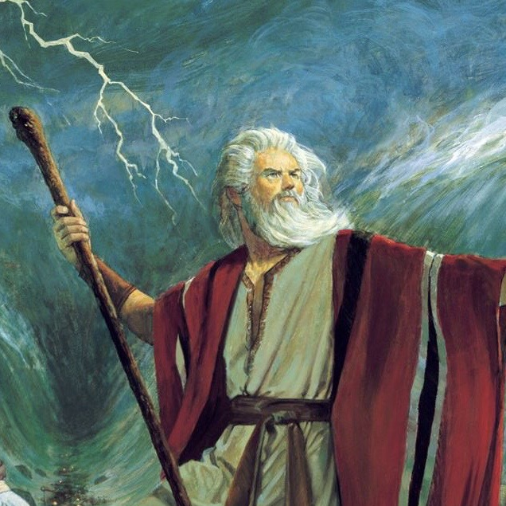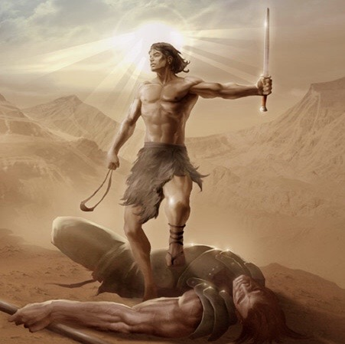; One who restored all things by grace.**

**Stories, crafts, games, songs!**

**April 4th-8th, 2022 Details to come.**

